1. 
2. Index is not fun without any document.
3. Formally when adding document to index, it’s said that we will **index** some document.  
   Indexing: To add document to shard.
4. 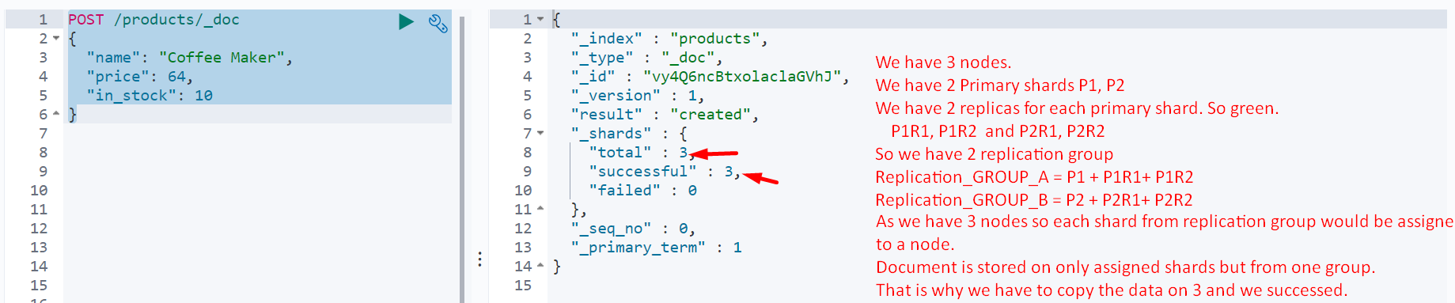
5. 
6. Above, in response, you can see field “_id” whose value is generated by system but we can pass our own.  
   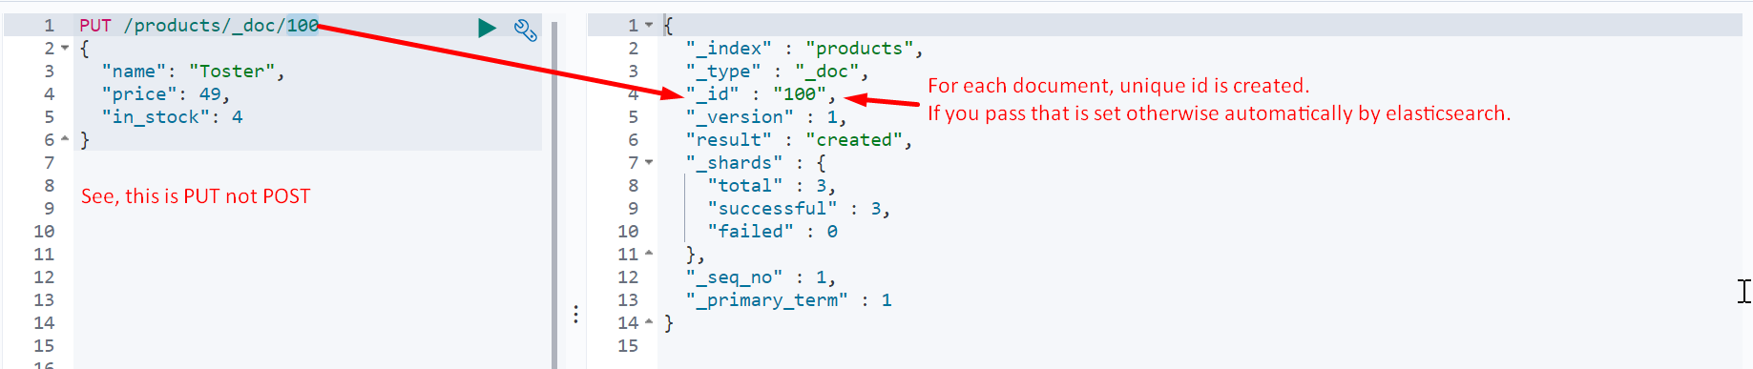
7. Save Document, Indexing Document, Saving Document, Indexing Document.  
   
8. Cases with POST
   1. When we do specify 100
      1. Case 01: Id exists:
         1. The previous doc would be replace completely by the new one otherwise go for _update API
      2. Case 02: Id doesn’t exist
         1. The doc would be added as nothing happens. No replacement.